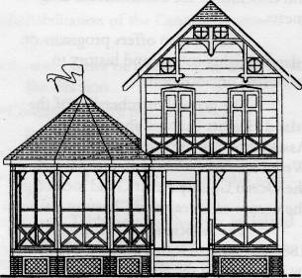

CULTURAL AND HERITAGE MEMBERSHIP APPLICATION

__ YES! I would like to Join The Island Heights Cultural and Heritage Association

The IHCHA membership year runs from January I through December 31. Dues are $10.00 per person per year, or $15 per couple living at the same address. Please make your check payable to I.H.C.H.A and mail application and membership fee to:

The Island Heights Cultural & Heritage Association, PO Box 670, Island Heights, NJ 08732

Name(s)_____________________

Address___________________________

(Street & PO)

City/State/Zip______________________

Phone_______________________ (Daytime #)

Phone_______________________ (Evening #)

I would like to give a gift membership to the person below:

NAME_____________________________

ADDRESS_________________________

CITY/STATE/ZIP_____________________

__I would like to further support your goals through a tax-deductible contribution to 'The Cottage Museum

Amount enclosed $_________________

